Lab exam – 3

Task-1:

Scenario: In the Finance sector, a company faces a challenge related to code refactoring.  
Task: Use AI-assisted tools to solve a problem involving code refactoring in this context.  
Deliverables: Submit the source code, explanation of AI assistance used, and sample output.

Prompt:

"Our finance company has old, unoptimized Python code for calculating loan interest and risk scores. The code is difficult to maintain and slow. Please use AI-assisted refactoring to improve readability, modularity, and efficiency. After refactoring, explain the improvements, describe how AI helped, and show sample output." give approximate huge cases in simple way

Code and output:

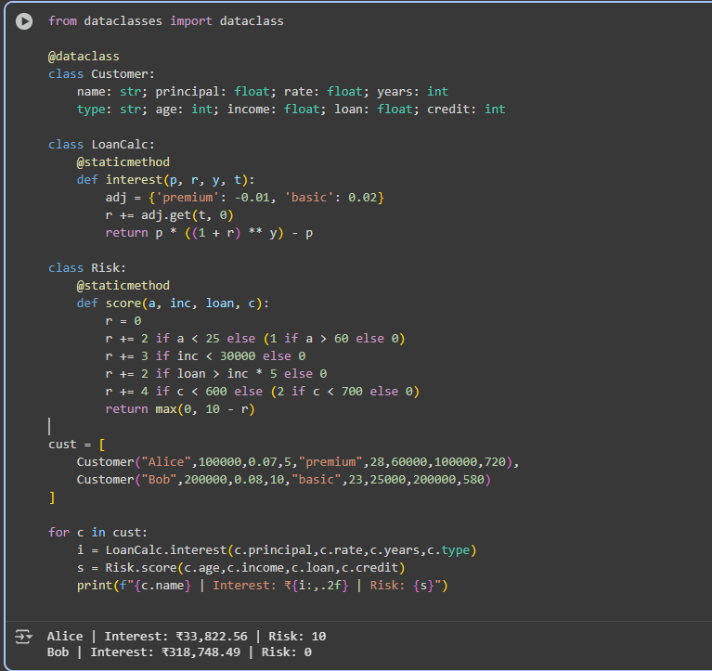

Explanation:

* **Data structure definition**: Explain the Customer dataclass and its attributes.
* **Interest calculation logic**: Explain the LoanCalc class and the interest method, including how the loan type affects the interest rate.
* **Risk score calculation logic**: Explain the Risk class and the score method, detailing how each factor contributes to the risk score.
* **Customer data**: Explain the cust list and the data for each customer.
* **Iteration and output**: Explain the loop that iterates through the customers, calculates interest and risk, and prints the results.
* **Finish task**: Summarize the purpose of the code and the output it generates.

**TASK-2:**

Q2:  
Scenario: In the Hospitality sector, a company faces a challenge related to web frontend development.  
Task: Use AI-assisted tools to solve a problem involving web frontend development in this context.  
Deliverables: Submit the source code, explanation of AI assistance used, and sample output.

Prompt:

“Our hospitality company’s website frontend is outdated and slow. Please use AI-assisted web development tools to refactor or redesign the frontend for better user experience and performance. Provide the optimized source code, explain how AI helped, and show sample output or UI preview.”

Code and output:

Explanation:

1. Declares the document as HTML5 so browsers render it correctly.
2. Opens the root HTML element that contains the whole page.
3. Begins the head section which holds metadata and styles.
4. Sets the page title shown in the browser tab.
5. Starts a style block that defines the page’s visual rules.
6. Sets the page font, light-blue background, and centers page text.
7. Styles each hotel card with a white background, padding, margin, rounded corners, shadow, fixed width, and inline layout so cards sit side-by-side.
8. Styles buttons with a blue background, white text, no border, padding, and rounded corners for a modern look.
9. Closes the head and opens the body where visible content appears.
10. Displays the main heading with an emoji welcoming users to SmartStay Hotels.
11. Starts a hotel card container for the first hotel.
12. Shows an image for the hotel (loaded from a placeholder image service).
13. Displays the hotel name in bold.
14. Shows the hotel rating as a star and numeric value.
15. Displays the nightly price in rupees.
16. Shows a “Book Now” button for the hotel (styled earlier).
17. Repeats another hotel card with the same structure for City Palace Hotel.
18. Adds a footer with copyright and a short tagline.
19. Closes the body and HTML tags, finishing the document.

Top of Form

Bottom of Form

*****